Week – 6 Hands-on 1: Create first React app

1. First we Install the Create-react-app by running the “npm install -g create-react-app” command

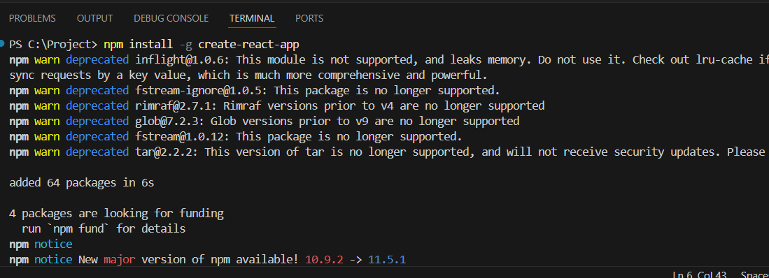

1. Then we creating the react application in the name of “myfirstapp” using “npx create-react-app myfirstapp”

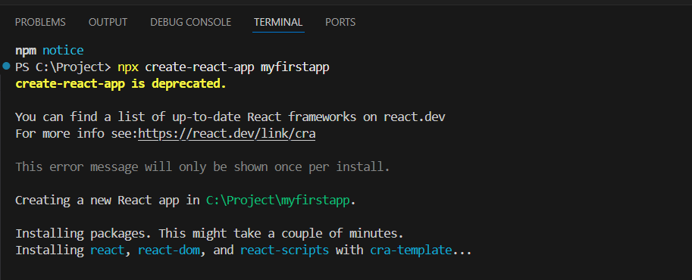

1. After opening the App.js file in our project replacing the content with my content

File name: App.js

import logo from './logo.svg';

import './App.css';

function App() {

return(

<h1>Welcome the first session of react</h1>

)

}

export default App;

1. Then we are running the application using npm start

OUTPUT:

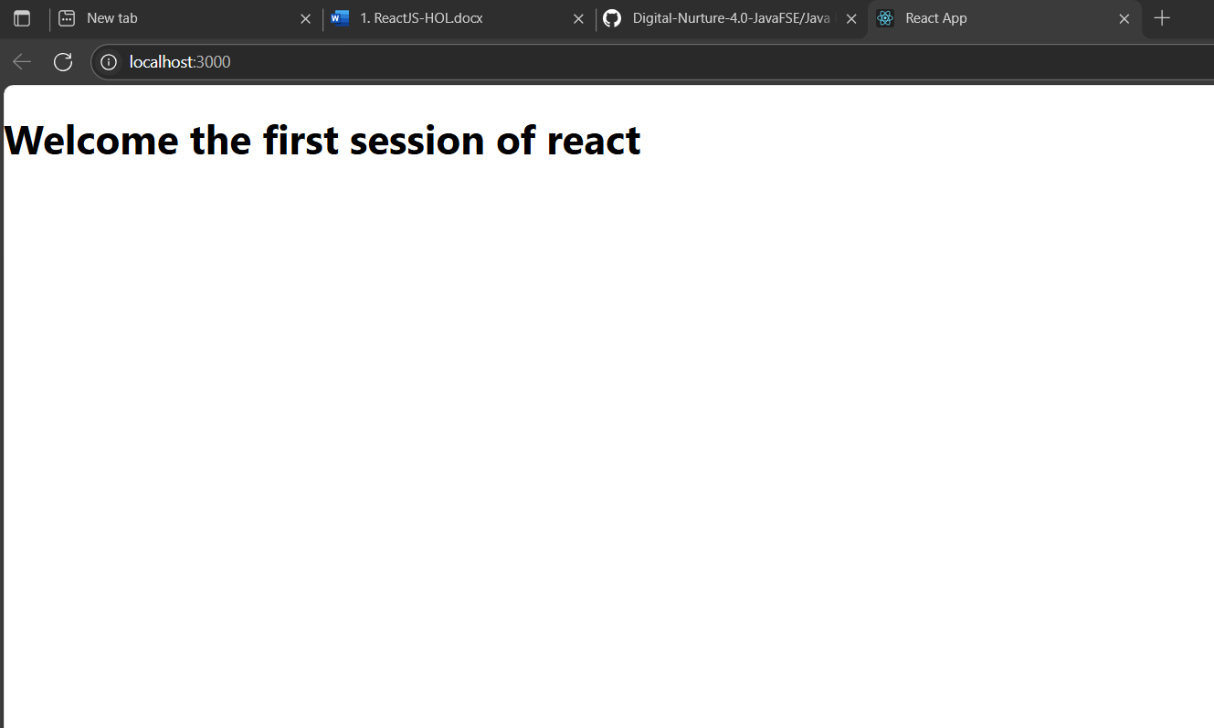

Hands-on 2: Create a react app for Student Management Portal:

1. Created a react app named studentapp and inside

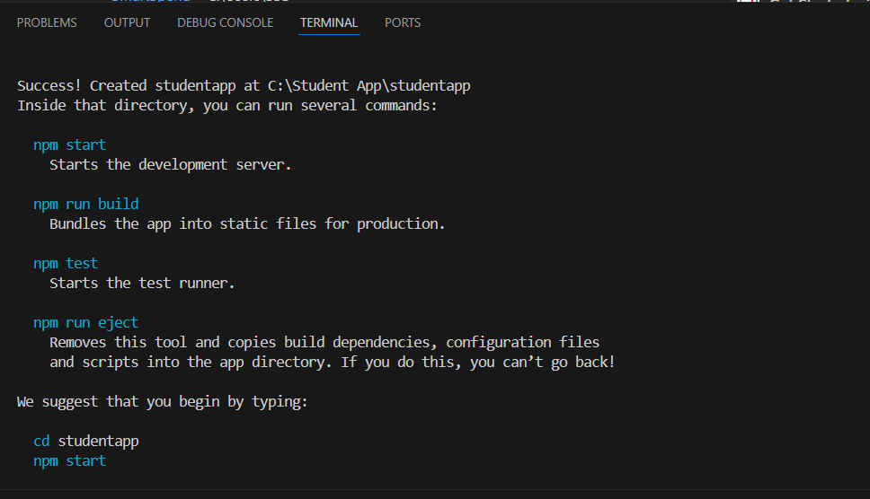

1. Creating the Components folder under the src folder. Inside the components folder create Home.js , About.js, Contact.js

File name: Home.js

import React, { Component } from "react";

class Home extends Component {

render() {

return (

<div>

<h3>Welcome to the home page of Student management portal</h3>

</div>

);

}

}

export default Home;

File name: About.js

import React, { Component } from "react";

class About extends Component {

    render() {

        return (

            <div>

                <h3>Welcome to the About page of Student management portal</h3>

            </div>

        );

    }

}

export default About;

File name: Contact.js

import React, { Component } from "react";

class Contact extends Component {

    render() {

        return (

            <div>

                <h3>Welcome to the Contact page of Student management portal</h3>

            </div>

        );

    }

}

export default Contact;

1. Now Editing the App.js to invoke the Home, About and Contact components

File name:App.js

import Home from './Components/Home';

import About from './Components/About';

import Contact from './Components/Contact';

function App() {

  return (

     <div>

      <Home/>

      <About/>

      <Contact/>

     </div>

  );

}

export default App;

1. Now running our application using the “npm start command”

OUTPUT (in console):

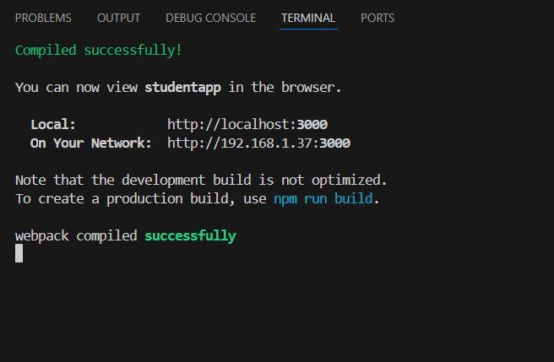

OUTPUT (in browser):

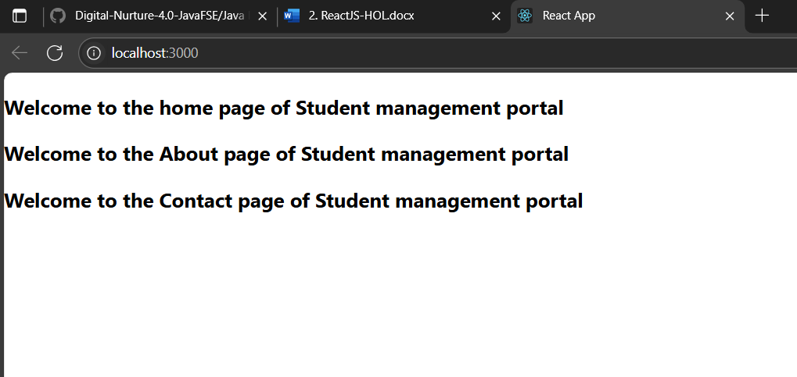

Hands-on 3: Create a Score calculator app:

1. Creating a React project named “scorecalculatorapp”

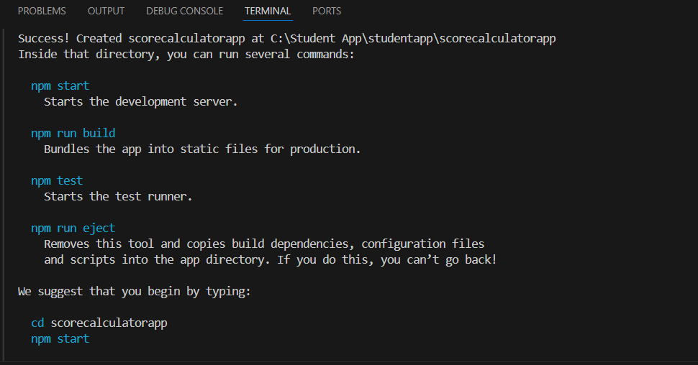

1. Create a new folder under Src folder with the name “Components”. Add a new file named “CalculateScore.js

File name:CalculateScore.js

import React from 'react';  
import '../stylesheets/mystyle.css';  
function CalculateScore(props){  
const avg = props.total/props.subjects;  
return(  
<div className = "score-card">  
<h2>Student Score Calculator</h2>  
<p><strong>Name: </strong> {props.name}</p>  
<p><strong>School: </strong>{props.school}</p>  
<p><strong>Total: </strong>{props.total}</p>  
<p><strong>Subjects: </strong>{props.subjects}</p>  
<p><strong>Average: </strong>{avg}</p>  
</div>  
);  
}  
export default CalculateScore;

1. Creating another folder named StyleSheets under src and we are creating a style page named mystyle.css

File name: mystyle.css

.score-card {  
border: 2px solid #4CAF50;  
padding: 20px;  
margin: 20px auto;  
width: 400px;  
border-radius: 10px;  
background-color: #f9f9f9;  
font-family: Arial, sans-serif;  
box-shadow: 2px 2px 12px #aaa;  
}  
.score-card h2 {  
color: #4CAF50;  
}

1. Editing the App.js to invoke the CalculateScore functional component

File name: App.js

import CalculateScore  from "./Component/CalculateScore";

function App() {

  return (

    <CalculateScore name="Karthikeyan" school="Vel tech" total="490" subjects="5"/>

  );

}

export default App;

OUTPUT:

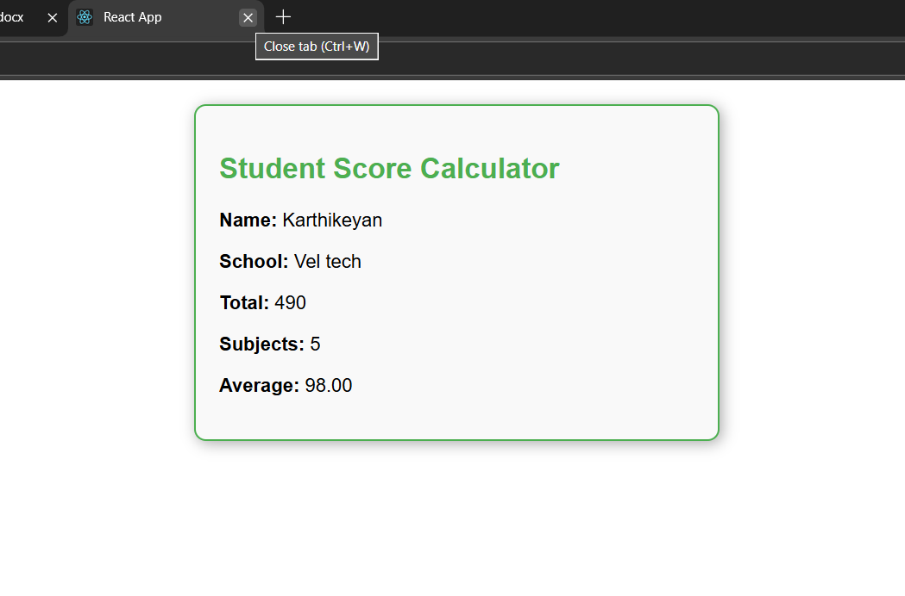

Hands-on 4: Create a blog post app:

1. Creating a React project named “blogapp”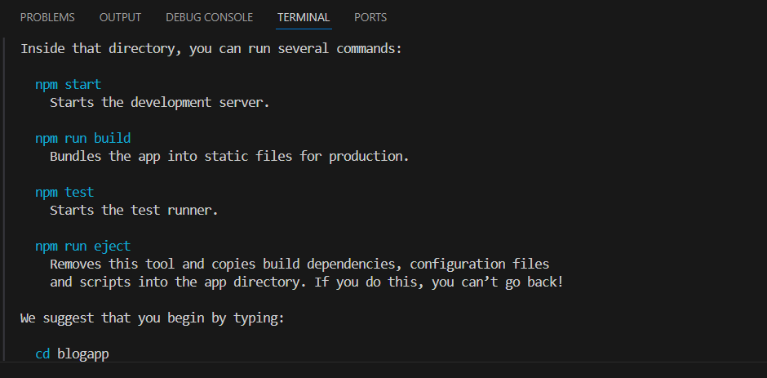
2. Creating a new folder called ‘components’, inside which we create Blog.js

import React from "react";

class Blog extends React.Component {

  constructor(props) {

    super(props);

    this.state = {

      posts: [],

      error: null,

    };

  }

  componentDidMount() {

    this.loadPosts();

  }

  loadPosts() {

    fetch("https://jsonplaceholder.typicode.com/posts")

      .then((response) => {

        if (!response.ok) throw new Error("Network response error");

        return response.json();

      })

      .then((data) => {

        this.setState({ posts: data });

      })

      .catch((error) => {

        this.setState({ error });

      });

  }

  componentDidCatch(error, info) {

    alert(`An error occurred: ${error.message}`);

  }

  render() {

    if (this.state.error) {

      return <h2>Error loading posts!</h2>;

    }

    return (

      <div>

        <h1>Blog Posts</h1>

        <ul>

          {this.state.posts.map((post) => (

            <li key={post.id}>

              <strong>{post.title}</strong>

              <p>{post.body}</p>

            </li>

          ))}

        </ul>

      </div>

    );

  }

}

export default Blog;

1. Invoking the blog component in our App component

File name: App.js

import './App.css';

import Blog from './Component/Blog';

function App() {

  return (

       <Blog/>

  );

}

export default App;

OUTPUT :

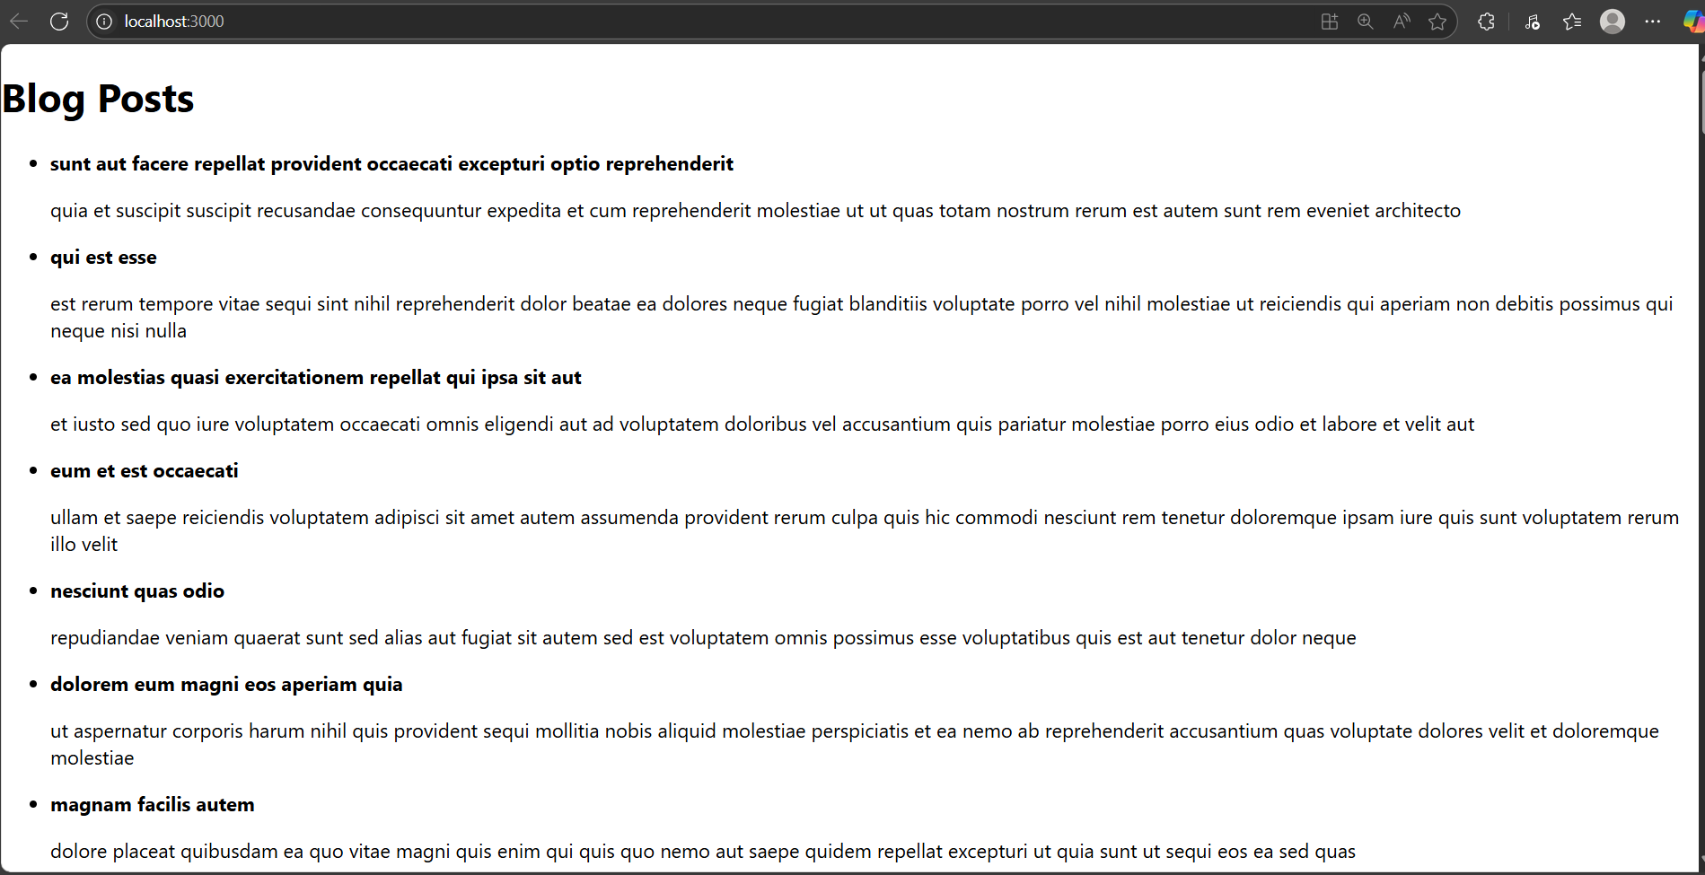

Hands-on 5: Creating and styling a cohort tracker app

1. Creating a app named “cohort tracker”

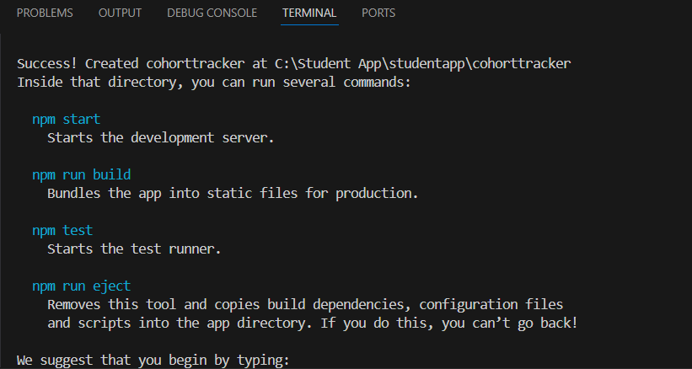

1. Now creating components folder under src , inside which we create CohortTracker.js

File name: CohortTracker

import React from 'react';

import '../StyleSheet/style.css';

const cohorts = [

  {

    id: "INTADMDF10 - Java FSD",

    startedOn: "22-Feb-2022",

    currentStatus: "Scheduled",

    coach: "Thomas Shelby",

    trainer: "Arthur Shelby",

  },

  {

    id: "ADM21JF014 - .Net FSD",

    startedOn: "10-Sep-2021",

    currentStatus: "Ongoing",

    coach: "Polly Gray",

    trainer: "John Shelby",

  },

  {

    id: "INTADMDF01 - Python FSD",

    startedOn: "12-Jan-2023",

    currentStatus: "Completed",

    coach: "Ada Shelby",

    trainer: "Finn Shelby",

  },

  {

    id: "ADM21JF015 - React FSD",

    startedOn: "15-Mar-2023",

    currentStatus: "Ongoing",

    coach: "Michael Gray",

    trainer: "Aberama Gold",

  },

  {

    id: "INTADMDF11 - Angular FSD",

    startedOn: "05-Apr-2024",

    currentStatus: "Scheduled",

    coach: "Lizzie Stark",

    trainer: "Esme Shelby",

  },

];

function CohortTracker() {

  return (

    <div className="gridContainer">

      {cohorts.map((cohort, idx) => (

        <div key={idx} className="cohortCard">

          <div>

            <span

              className={

                cohort.currentStatus === "Ongoing"

                  ? "ongoingTitle"

                  : "otherTitle"

              }

            >

              {cohort.id}

            </span>

          </div>

          <div>

            <strong>Started On</strong>

            <br />

            <span>{cohort.startedOn}</span>

          </div>

          <div>

            <strong>Current Status</strong>

            <br />

            <span>{cohort.currentStatus}</span>

          </div>

          <div>

            <strong>Coach</strong>

            <br />

            <span>{cohort.coach}</span>

          </div>

          <div>

            <strong>Trainer</strong>

            <br />

            <span>{cohort.trainer}</span>

          </div>

        </div>

      ))}

    </div>

  );

}

export default CohortTracker;

export default CohortTracker;

1. Now creating a StyleSheet folder , inside that creating style.css

File name: style.css

.gridContainer {

  display: grid;

  grid-template-columns: repeat(3, 1fr);

  gap: 2rem;

  justify-items: center;

  align-items: center;

  margin: 3rem auto;

  max-width: 1200px;

}

.cohortCard {

  border: 1px solid #ccc;

  border-radius: 10px;

  padding: 1.5rem;

  min-width: 230px;

  max-width: 260px;

  background: #fff;

  font-family: Arial, sans-serif;

  box-shadow: 2px 4px 10px rgba(0, 0, 0, 0.07);

}

.ongoingTitle {

  color: #2e7d32;

  font-weight: bold;

  font-size: 1.1rem;

}

.otherTitle {

  color: #1a237e;

  font-weight: bold;

  font-size: 1.1rem;

}

1. Now invoking out CohortTracker component in our App.js

File name:App.js

import CohortTracker from "./Components/CohortTracker";

function App() {

  return (

    <CohortTracker/>

  );

}

export default App;

OUTPUT:

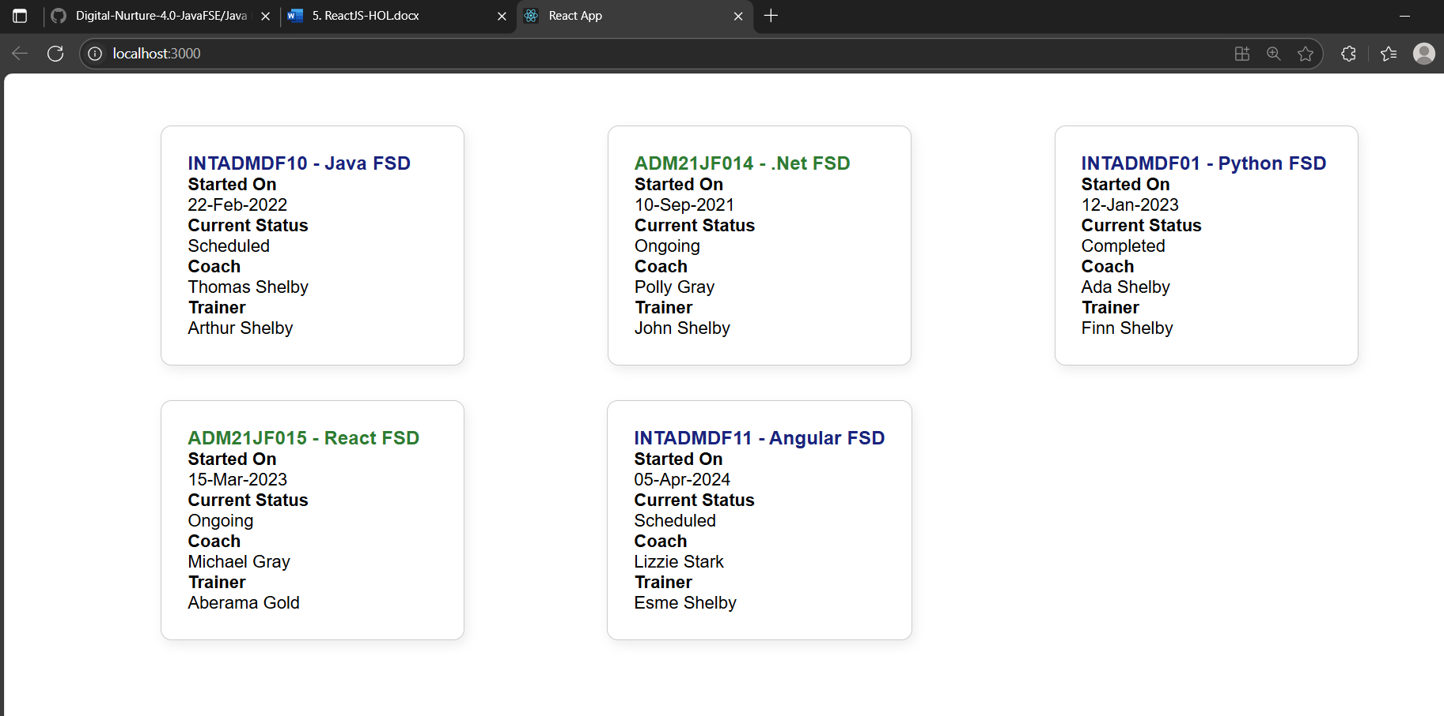

As mentioned in the hands-on document different color for ongoing  
cohorts and cohorts, We have applied this style to the dummy cohorts  
that was created by mimicking card details from the output screenshot  
in the hands-on document